**DevOps CaseStudy- HandsON**

Access Windows

Install Snyk  
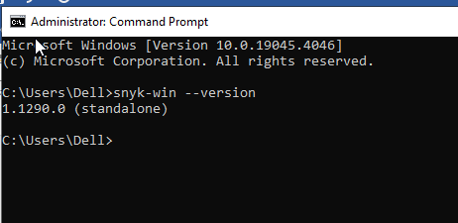

Install NPM

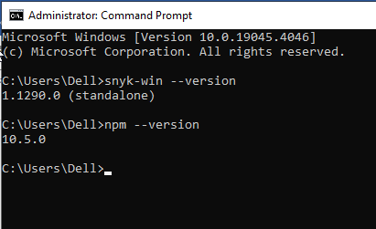

**Install Java**

**Install Jenkins on Windows – Refer to the other document shared**[**https://dashboard.ngrok.com/get-started/setup/windows**](https://dashboard.ngrok.com/get-started/setup/windows) 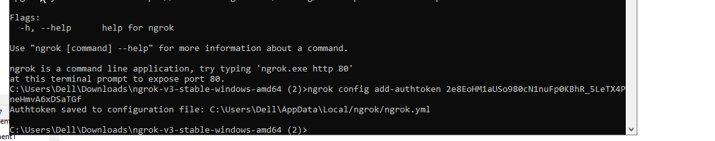

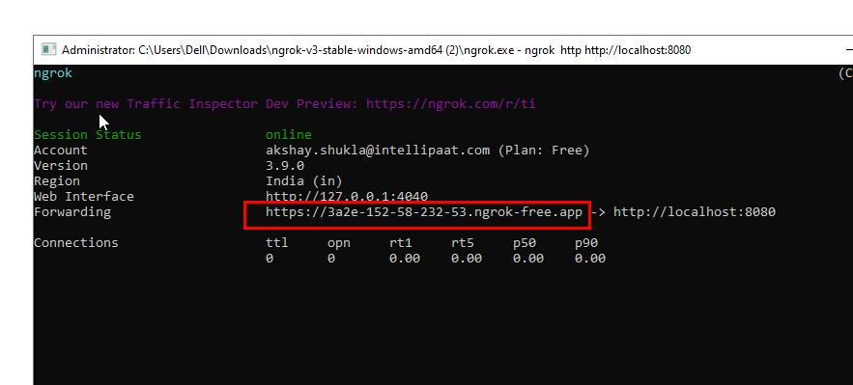

**Terraform:**

**<https://releases.hashicorp.com/terraform/1.8.2/terraform_1.8.2_windows_386.zip>**